**NBA Player Analysis Report**

**Introduction**

This report offers a detailed look at NBA player stats, highlighting key metrics like agility, weight, body fat, and other physical attributes. I used Microsoft Excel for data cleaning and analysis, ensuring the insights is both accurate and reliable. The Power BI dashboard I created visualizes the data, making it easier for team managers, coaches, and sports analysts to spot trends and gain valuable insights.

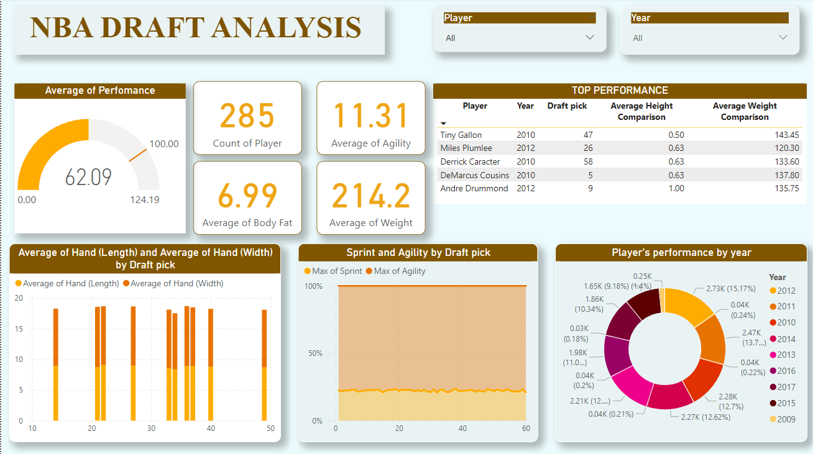

**Summary of Analysis**

1. **Overall Player Statistics**

* **Total Players Analyzed:** 285
* **Average Agility:** 11.31%
* **Average Body Fat:** 6.99%
* **Average Weight:** 214.2 lbs.

1. **Average Draft Pick Position:**

The average draft pick position is 29 indicating that the dataset includes a mix of first and second-round picks, providing insights into a broad range of talent levels.

1. **Top Performer**

The table lists the top performers in terms of sprint time, vertical jump (max reach), and agility. The top performer in the year:-

* Luke Harangody (2009)
* Tiny Gallon (2010)
* Nikola Vucevic (2011)
* Miles Plumiee
* Tony Mitchell
* Noah Vonleh
* Richaun Holmes
* Marquese Chriss
* Tony Bradley

1. **Player’s Performance**

The donut chart visually represents the player's performance over the year, offering a detailed breakdown of various performance metrics. Each segment of the chart corresponds to specific aspects of the player's game, making it easier to identify strengths and areas for improvement. This clear and concise visualization allows coaches, managers, and analysts to quickly assess overall performance trends.

**Key Findings**

* **High Variation in Physical Attributes:**

The analysis revealed significant variations in physical attributes such as vertical reach, weight, and body fat among players. This indicates diverse physical conditioning and genetic factors at play.

* **Draft Pick Trends:**

The trends in sprint and agility metrics based on draft picks suggest that higher draft picks tend to have better physical performance, reflecting the scouting and selection process's effectiveness.

* **Percentile Rank Analysis**

The percentile rank provides a comparative measure of a player's performance or attributes relative to their peers. For example, a player in the 90th percentile for agility is faster than 90% of other players, offering a clear benchmark for evaluating individual performance against the broader player pool. This metric helps coaches and analysts identify standout players and areas for improvement.

* **Body Mass Index (BMI) Analysis**

Body Mass Index (BMI) is used to assess a player's body composition by relating weight to height. This metric helps evaluate whether a player is within a healthy range, considering their specific position and role on the team. An optimal BMI can indicate good physical conditioning, which is crucial for performance and injury prevention.

* **Correlation Between Height with Shoes and Performance**

The analysis reveals a correlation between a player's height with shoes and their performance metrics. Taller players, as measured with shoes, may exhibit advantages in areas such as rebounding, shot-blocking, and shooting over defenders. Understanding this correlation helps in determining how height contributes to overall player effectiveness and can guide decisions on player roles and strategies.

**Recommendations:-**

1. **Player Positioning:** Leverage the correlation between height with shoes and performance by strategically positioning taller players in roles that capitalize on their height, such as rebounding, shot-blocking, and defending.
2. **Targeted Training:** Develop training programs that enhance the performance of players across different height ranges, ensuring that both taller and shorter players maximize their unique physical advantages.
3. **Recruitment Strategy:** Consider height with shoes as a key factor in recruitment, especially for positions where height is strongly correlated with success, such as centres and forwards.
4. **Performance Monitoring:** Continuously monitor the correlation between height and performance metrics to adjust training and development strategies, ensuring that players reach their full potential regardless of height.
5. **Customized Conditioning:** Implement conditioning programs tailored to height-related performance needs, focusing on agility for shorter players and strength for taller players to optimize their contribution to the team.

**Conclusion**

Our analysis of NBA players' physical attributes, including height with shoes, and their performance metrics reveals key insights into how these factors influence on-court success. The correlation data underscores the importance of leveraging physical characteristics for optimized player roles and development. By integrating these findings into recruitment strategies and training programs, teams can enhance player performance and overall team effectiveness, gaining a competitive edge in the league.